

|  |  |
| --- | --- |
| **JWL-1015**  **JWL-1015VS** | **Wood Lathe** |
| **JWL-1015-M…...719100M..****1~230V,50Hz**  **JWL-1015VS-M..719110M..1~230V,50Hz** |

**PARTS LIST**



**JPW (Tool) AG**

Tämperlistr. 5

CH-8117 Fällanden

Switzerland

Phone +41 44 806 47 48

Fax +41 44 806 47 58

[www.jettools.com](http://www.jettools.com)

P-719100M 2014 - 01

JWL-1015 Lathe – Exploded View

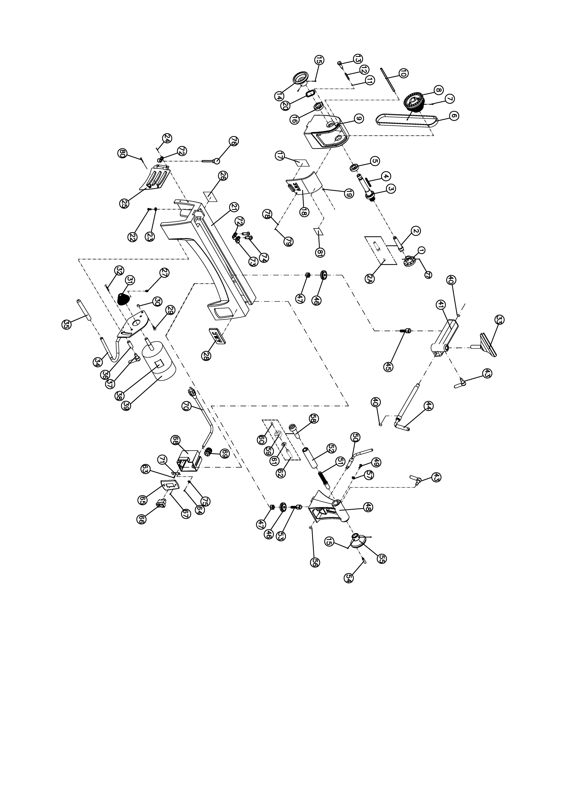 **JWL-1015 Lathe – Parts List**

Index No Part No Description Size Qty

JWL1015-HAE Headstock Assembly (*includes #3 thru #20,#81)* 1

1 6294736E Faceplate 3”, M33 1

2 JWL1642-102 Spur Center MT2 1

2A JML-3A Center Point for Spur Center 1

3 JWL1015-103E Spindle M33x3.5mm 1

4 JML-5 Key 5x25mm 1

5 BB-6005VV Ball Bearing 6005VV 1

6 JML-20 V-Belt 240J 1

7 TS-0267041 Socket Set Screw 1/4”-20x3/8” 2

8 JWL1015-108 Spindle Pulley 1

9 JWL1015-109E Headstock 1

10 JWL1015-110 Pin 1

11 JML1014-187 C-Ring STW-9 1

12 JML1014-188 Spring 1

13 JML1014-189 Index Pin 1

14 JWL1221VS-123 Handwheel 1

15 TS-0267021 Set Screw 1/4”-20x1/4” 4

16 BB-6004VV Ball Bearing 6204VV 1

17 JWL1015-117E Speed Label 1

18 JWL1015-118E Pulley Access Door 1

19 JWL1015-119 Spring 1

20 JML-8 Wave Washer 1

21 JWL1015-121E Bed 1

22 TS-0207061 Socket Head Cap Screw 1/4”-20x1” 4

23 TS-0720071 Lock Washer 1/4” 4

24 JWL1015-124 Socket Head Button Screw #10-24x1/4” 2

25 JWL1015-125E Motor Access Door 1

26 JWL1015-126E I.D Label 1

27 TS-0267041 Socket Set Screw 1/4”-20x3/8” 2

28 JET-92 JET Logo with 3M Adhesive 92x38mm 1

29 TS-0051051 Hex Cap Screw 5/16”-18x1” 1

30 TS-0640081 Nylon Lock Hex Nut 5/16”-18 1

31 JML-28 Motor Pulley 1

32 JWL1015-132 Socket Head Flat Screw 1/4”-20x1/2” 2

33 JML-42 Tool Rest 6” 1

34 JWL1015-134 Motor Bracket 1

35 JWL1221VS-266 Rubber Cover 1

36 JWL1015-136 Bushing 1

37 JWL1015-137 Lock Handle Assembly, Motor Plate 1

38 JWL1015-138E Motor Label 1

39 JWL1015-139E Motor (Included #38) 1/2HP, 1Ph, 115V 1

JML-35-1E Capacitor (not shown) 12uf,400 VAC 1

JML-35-2E Capacitor Cover (not shown) 1

JML-35-3 Motor Fan Cover (not shown) 1

JWL1015-TBA Toolrest Base Assembly (*includes #40 thru #47)* 2

40 JML-9 C-Ring STW-12 2

41 JWL1015-141 Tool Rest Body 1

43 JML-59A Lock Handle Assembly 5/16”-18x3/4” 2

44 JML-50 Eccentric Locking Rod 1

45 JML-43 Bolt 1

46 JML-44 Clamp 2

47 JML-81 Clamp Nut 2

JWL1015-TA Tailstock Assembly (*includes #15,43,46 thru #57)* 1

48 JWL1015-148 Tailstock 1

49 TS-0255031 Socket Head Button Screw 5/16”-18x5/8” 1

50 JML-58 Eccentric Rod, Tailstock 1

51 JWL1015-151 Lead Screw 1

52 JML-55 Quill 1

53 JML-64 Bolt 1

54 JWL1221VS-222 Handle 1

Index No Part No Description Size Qty

55 JWL1221VS-223 Handwheel 1

56 JML-63 C-Ring STW-10 1

57 TS-0680031 Flat Washer 5/16” 1

58 708331 Live Center Assembly (*includes #59 thru #62)* 1

59 JML-52 Live Center Head 1

60 JML-52A Center Point for Live Center 1

61 BB-6002ZZ Ball Bearing 6002ZZ 1

62 JML-54 Live Center Shaft 1

63 JWL1015-163 Tapping Screw M3.5x6mm 1

64 TS-1533032 Pan Head Screw M5x10 2

65 JWL1015-165E Switch Cover 1

66 JML-65E On-Off Switch 1

67 TS-081C052 Pan Head Screw #10-24x3/4” 2

68 JWL1015-168 Switch Box 1

69 JML-70E Strain Relief 2

70 JWL1015-170E Power Cord 1

71 JWL1015-171 Ground Plate 1

72 JWL1015-172 Clamp 5/16”  2

73 JWL1221VS-276 Clamp 1/2”  1

74 TS-081C022 Pan Head Screw #10-24x3/8” 2

75 TS-0733041 External Tooth Lock Washer 1/4” 2

76 JML-11 Knockout Rod 1

77 6295796 Nylon Insert Socket Set Screw 1/4-20x3/8” 2

78 JWL1221VS-136E O-Ring 1

79 TS-081C042 Screw #10-24x5/8” 1

80 TS-081C022 Pan Head Screw #10-24x3/8 1

81 JWL1221VS-137E Warning Label 1

JWL-1015VS Lathe – Exploded View

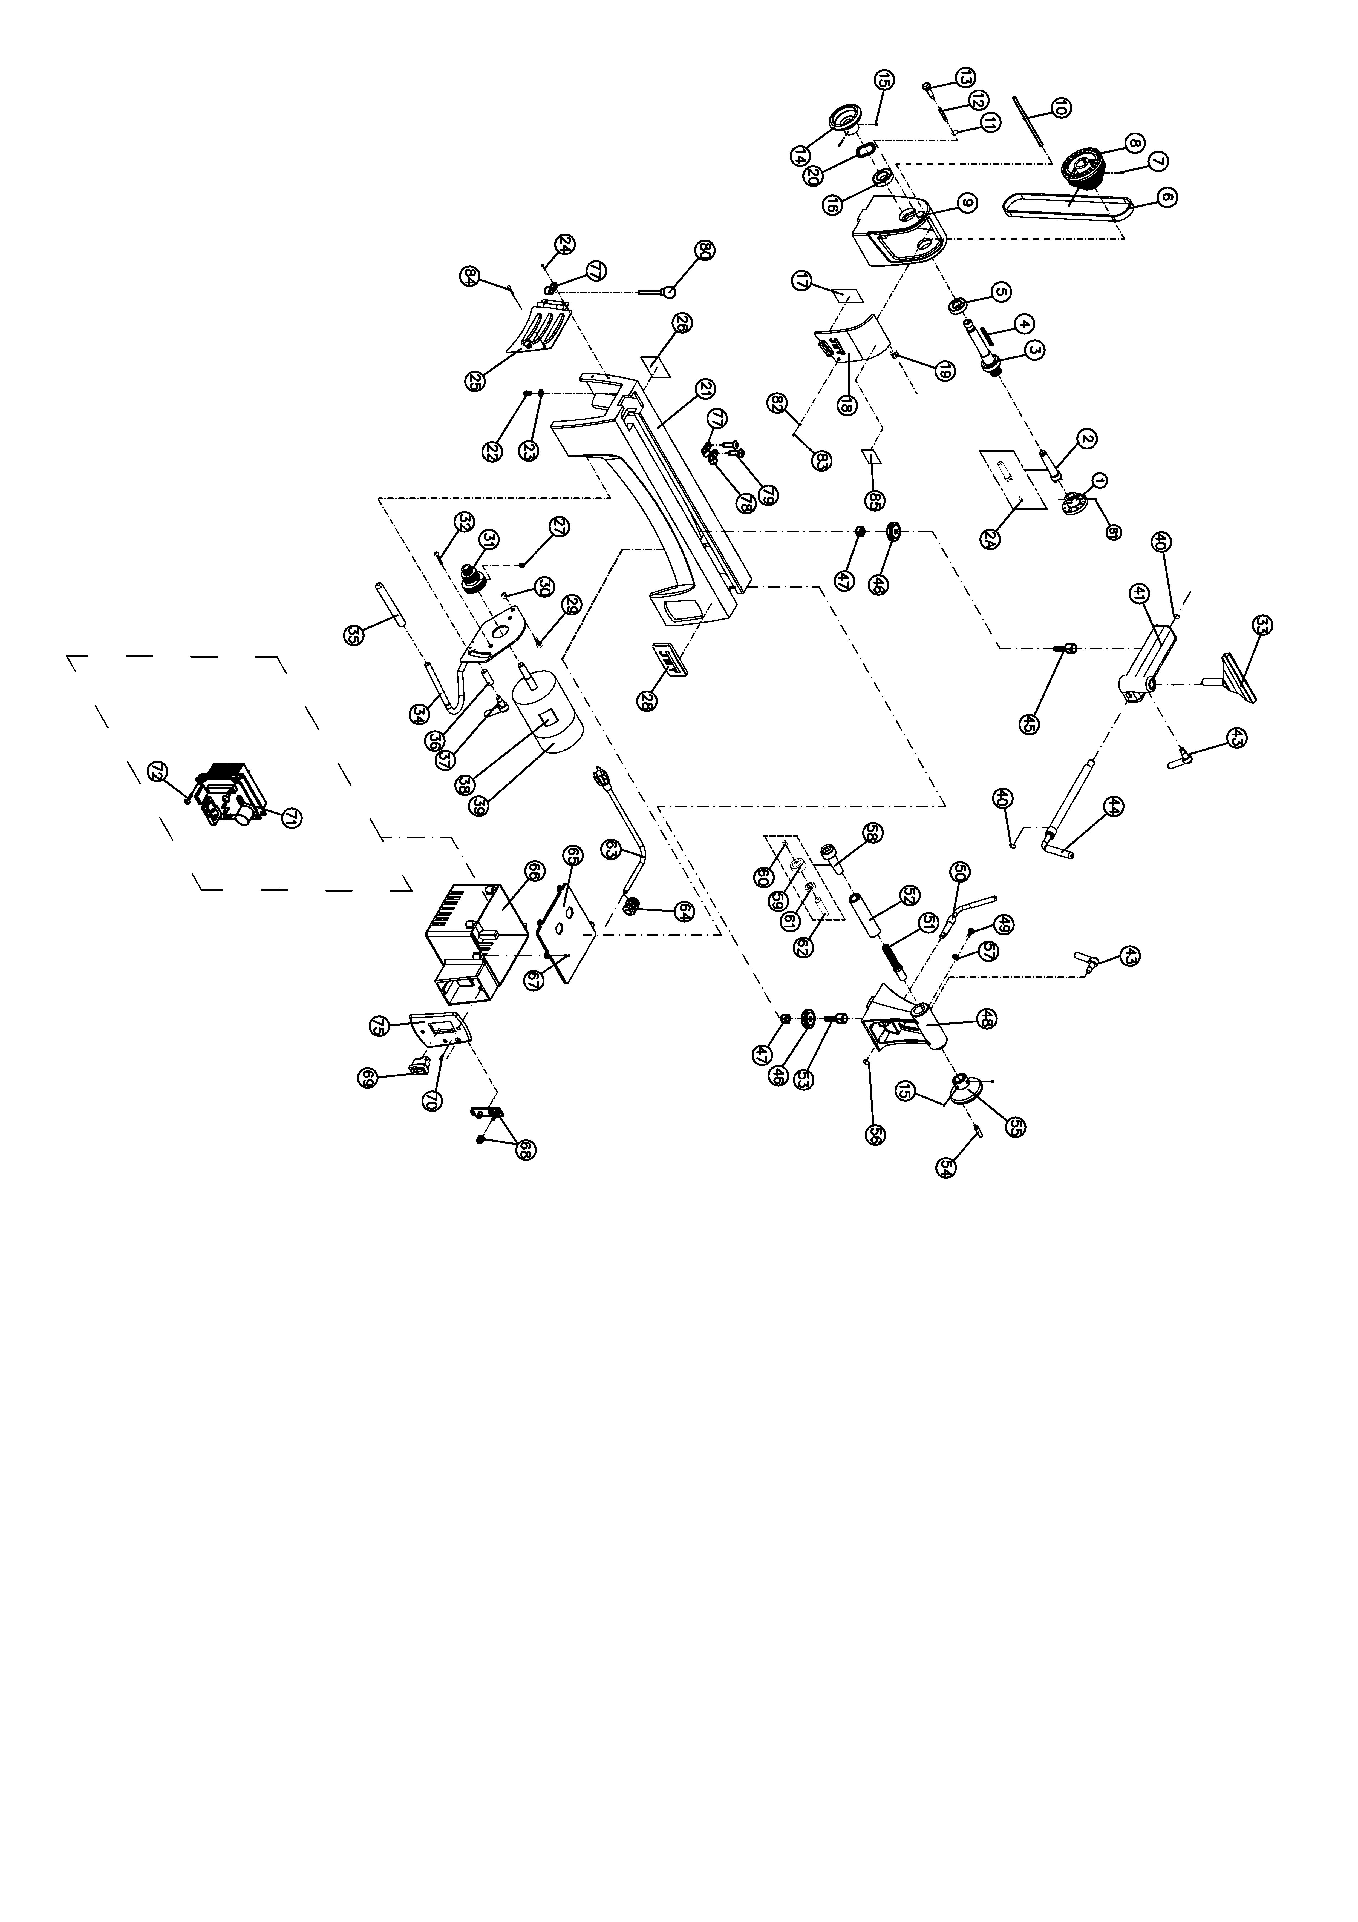

JWL-1015VS Lathe – Parts List

Index No Part No Description Size Qty

JWL1015VS-HAE Headstock Assembly (*includes #3 thru #2 & #85)* 1

1 JML-2 Faceplate 3” 1

2 JML-3 Spur Center MT2 1

2A JML-3A Center Point for Spur Center 1

3 JWL1015-103E Spindle M33x3.5mm 1

4 JML-5 Key 5x25mm 1

5 BB-6005VV Ball Bearing 6005VV 1

6 JML-20 V-Belt 240J 1

7 TS-0267041 Socket Set Screw 1/4”-20x3/8” 2

8 JWL1015VS-108 Spindle Pulley 1

9 JWL1015-109E Headstock 1

10 JWL1015-110 Pin 1

11 JML1014-187 C-Ring STW-9 1

12 JML1014-188 Spring 1

13 JML1014-189 Index Pin 1

14 JWL1221VS-123 Handwheel 1

15 TS-0267021 Set Screw 1/4”-20x1/4” 4

16 BB-6004VV Ball Bearing 6204VV 1

17 JWL1015VS-117E Speed Label 1

18 JWL1015-118E Pulley Access Door 1

19 JWL1015-119 Spring 1

20 JML-8 Wave Washer 1

21 JWL1015-121E Bed 1

22 TS-0207061 Socket Head Cap Screw 1/4”-20x1” 4

23 TS-0720071 Lock Washer 1/4” 4

24 JWL1015-124 Socket Head Button Screw #10-24x1/4” 2

25 JWL1015-125E Motor Access Door 1

26 JWL1015VS-126E I.D Label 1

27 TS-0267041 Socket Set Screw 1/4”-20x3/8” 2

28 JET-92 JET Logo with 3M Adhesive 92x38mm 1

29 TS-0051051 Hex Cap Screw 5/16”-18x1” 1

30 TS-0640081 Nylon Lock Hex Nut 5/16”-18 1

31 JWL1015VS-131 Motor Pulley 1

32 TS-0254021 Socket Head Button Screw 1/4”-20x1/2” 2

33 JML-42 Tool Rest 6” 1

34 JWL1015-134 Motor Bracket 1

35 JWL1221VS-266 Rubber Cover 1

36 JWL1015-136 Bushing 1

37 JWL1015-137 Lock Handle Assembly, Motor Plate 1

38 JWL1015VS-138E Motor Label 1

39 JWL1015VS-139E Motor 1/2 HP 1

JWL1015VS-MCB Motor Carbon Brush with Cap (not shown) 2

JWL1015VS-MFC Motor Fan Cover (not shown) 1

JWL1015VS-MF Motor Fan (not shown) 1

JWL1015-TBA Toolrest Base Assembly (*includes #40 thru #47)* 2

40 JML-9 C-Ring STW-12 2

41 JWL1015-141 Tool Rest Body 1

43 JML-59A Lock Handle Assembly 5/16”-18x3/4” 2

44 JML-50 Eccentric Locking Rod 1

45 JML-43 Bolt 1

46 JML-44 Clamp 2

47 JML-81 Clamp Nut 2

JWL1015-TA Tailstock Assembly (*includes #15,43,46 thru #57)* 1

48 JWL1015-148 Tailstock 1

49 TS-0255031 Socket Head Button Screw 5/16”-18x5/8” 1

50 JML-58 Eccentric Rod, Tailstock 1

51 JWL1015-151 Lead Screw 1

52 JML-55 Quill 1

53 JML-64 Bolt 1

54 JWL1221VS-222 Handle 1

Index No Part No Description Size Qty

55 JWL1221VS-223 Handwheel 1

56 JML-63 C-Ring STW-10 1

57 TS-0680031 Flat Washer 5/16” 1

58 708331 Live Center Assembly (*includes #59 thru #62)* 1

59 JML-52 Live Center Head 1

60 JML-52A Center Point for Live Center 1

61 BB-6002ZZ Ball Bearing 6002ZZ 1

62 JML-54 Live Center Shaft 1

JWL1015VS-CAE Controller Assembly (*includes #63 thru #75)* 1

63 JWL1015VS-163E Power Cord 1

64 JML-70E Strain Relief 2

65 JWL1015VS-165E Plate 1

66 JWL1015VS-166 Switch Cover 1

67 JWL1015VS-167 Tapping Screw M3x12 4

68 JWL1015VS-168E Control Potentiometer Assembly 1

69 JML-65E On-Off Switch 1

70 JWL1015VS-170 Tapping Screw 2

71 JWL1015VS-171E Circuit Board Assembly 1

72 JWL1221VS-302 Tapping Screw M3x19 4

73 JWL1015VS-174 Connect Cord (VR to PC board; not shown) 1

74 JWL1221VS-324 Connect Cord (Power cord to PC board; not shown) 1

75 JWL1015VS-175E Switch Cover   1

77 JWL1015-172 Clamp 5/16”  2

78 JWL1221VS-276 Clamp 1/2”  1

79 TS-081C022 Pan Head Screw #10-24x3/8” 2

80 JML-11 Knockout Rod

81 6295796 Nylon Insert Socket Set Screw 1/4-20x3/8” 2

82 JWL1221VS-136E O-Ring 1

83 TS-081C042 Screw #10-24x5/8” 1

84 TS-081C022 Pan Head Screw #10-24x3/8 1

85 JWL1221VS-137E Warning Label 1

**JWL-1015-M…..719100M….1~230V,50Hz**

|  |  |  |  |
| --- | --- | --- | --- |
|  | **colour of strands** | **Litzenfarben** | **couleur des cordons** |
| **BK** | **black** | **schwarz** | **noir** |
| **WH** | **white** | **weiß** | **blanc** |
| **BU** | **blue** | **blau** | **bleu** |
| **YE** | **yellow** | **gelb** | **jaune** |
| **RD** | **red** | **rot** | **rouge** |
| **BN** | **brown** | **braun** | **brun** |
| **GY** | **grey** | **grau** | **gris** |
| **GNYE** | **green-yellow** | **grün-gelb** | **vert-jaune** |
| **OG** | **orange** | **orange** | **orange** |
| **VT** | **violet** | **violett** | **violet** |

|  |  |  |  |
| --- | --- | --- | --- |
|  | **meaning of symbol** | **Bedeutung der Zeichen** | **interprétation** |
| **M** | **motor** | **Motor** | **moteur** |
| **S** | **switch** | **Schalter** | **interrupteur** |
| **C** | **condenser** | **Kondensator** | **condensateur** |
| **E** | **electronic unit** | **Elektronik Einheit** | **unité électronique** |
| **F** | **fuse** | **Sicherung** | **fusible** |
| **RS** | **reversing switch** | **Drehrichtungsschalter** | **commu. droite/gauche** |
| **CS** | **centrifugal switch** | **Fliehkraftschalter** | **déclencheur centrifuge** |
| **OL** | **overload cut-off** | **Überlastschutzschalter** | **déclencheur surcharge** |
| **LS** | **limit switch** | **Positionsendschalter** | **micro** |

JML-1014

**JWL-1015VS-M..719110M….1~230V,50Hz**

|  |  |  |  |
| --- | --- | --- | --- |
|  | **colour of strands** | **Litzenfarben** | **couleur des cordons** |
| **BK** | **black** | **schwarz** | **noir** |
| **WH** | **white** | **weiß** | **blanc** |
| **BU** | **blue** | **blau** | **bleu** |
| **YE** | **yellow** | **gelb** | **jaune** |
| **RD** | **red** | **rot** | **rouge** |
| **BN** | **brown** | **braun** | **brun** |
| **GY** | **grey** | **grau** | **gris** |
| **GNYE** | **green-yellow** | **grün-gelb** | **vert-jaune** |
| **OG** | **orange** | **orange** | **orange** |
| **VT** | **violet** | **violett** | **violet** |

|  |  |  |  |
| --- | --- | --- | --- |
|  | **meaning of symbol** | **Bedeutung der Zeichen** | **interprétation** |
| **M** | **motor** | **Motor** | **moteur** |
| **S** | **switch** | **Schalter** | **interrupteur** |
| **C** | **condenser** | **Kondensator** | **condensateur** |
| **E** | **electronic unit** | **Elektronik Einheit** | **unité électronique** |
| **F** | **fuse** | **Sicherung** | **fusible** |
| **RS** | **reversing switch** | **Drehrichtungsschalter** | **commu. droite/gauche** |
| **CS** | **centrifugal switch** | **Fliehkraftschalter** | **déclencheur centrifuge** |
| **OL** | **overload cut-off** | **Überlastschutzschalter** | **déclencheur surcharge** |
| **LS** | **limit switch** | **Positionsendschalter** | **micro** |

